Sales Analysis for Pizza

KPI-I

- Total revenue generated.
select SUM(total_price) Total_Revenue from pizza_sales;

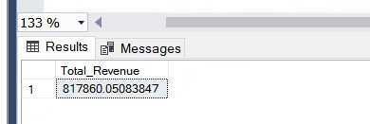

- Average order value.
select (SUM(total_price)/(count(distinct order_id))) Average_Order_Value from pizza_sales;
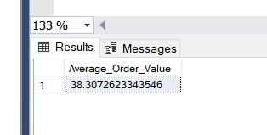

- Total pizza sold
select SUM(quantity) Total_pizza_sold from pizza_sales;
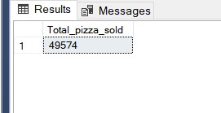

- Total orders
select count(distinct order_id) Total_orders from pizza_sales;

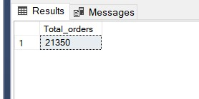

- Average pizza per order
select (SUM(quantity)/Count(distinct order_id)) Average_pizza_per_order from pizza_sales;

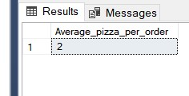

KPI-II

- Daily trend for orders.
select DATENAME(DW, order_date) order_day , count(distinct order_id) Toatl_orders from pizza_sales
group by DATENAME(DW, order_date);
- Hourly Trend for total orders.
SELECT DATEPART(HOUR, CAST(order_time AS DATETIME)) AS order_hour,
COUNT(DISTINCT order_id) AS Total_orders
FROM pizza_sales
GROUP BY DATEPART(HOUR, CAST(order_time AS DATETIME))
ORDER BY DATEPART(HOUR, CAST(order_time AS DATETIME));
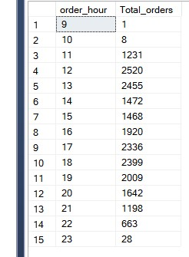

- Percentage of sales by pizza category.
SELECT
pizza_category,
CAST(SUM(total_price) AS DECIMAL(10,2)) AS total_revenue,
CAST(SUM(total_price)*100.0/(SELECT SUM(total_price) FROM pizza_sales) AS DECIMAL(10,2)) AS PCT
FROM
pizza_sales
GROUP BY
pizza_category;

- Percentage of sales by pizza size.
SELECT
pizza_size,
CAST(SUM(total_price) AS DECIMAL(10,2)) AS total_revenue,
CAST(SUM(total_price)*100.0/(SELECT SUM(total_price) FROM pizza_sales) AS DECIMAL(10,2)) AS PCT
FROM
pizza_sales
GROUP BY
pizza_size;
- Total pizza sold per category .
select pizza_category, round(sum(total_price)/count(distinct pizza_category),2) from pizza_sales
group by pizza_category;
- Top 5 Sales.
select top 5 pizza_name, SUM(total_price) Total_revene from pizza_sales
group by pizza_name
Order by Total_revene DESC;
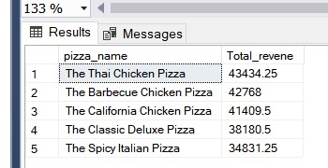

- Bottom 5 Sales.
select top 5 pizza_name, SUM(total_price) Total_revene from pizza_sales
group by pizza_name
Order by Total_revene ASC;
